**Project Status Report (7/22/16): Spatial Variability of Symbiodinium and Color Morph of *Montipora capitata* in Kaneohe Bay**

*Fieldwork:*

Protocol overview

1. 10 weights with attached float deployed at each reef area
2. Nearest *M. capitata* colony to each float cattle-tagged, photographed, fragmented and GPS waypoint collected
3. Snip of each fragment placed in SDS/DNAB and remaining fragment frozen in liquid nitrogen

480 total colonies tagged

* 30 colonies tagged per patch reef (10 leeward, windward, top)
  + 14 patch reefs completed (5 north bay, 5 central bay, 4 south bay)
    - Will be 15 (final southern reef HIMB completed week of July 25th)
* 20 colonies tagged per fringing reef site (10 slope, top)
  + 6 completed (3 north bay, 2 central bay, 1 south bay)
    - Will be 9 (remaining 1 central, 2 southern reefs completed within next 2 weeks)

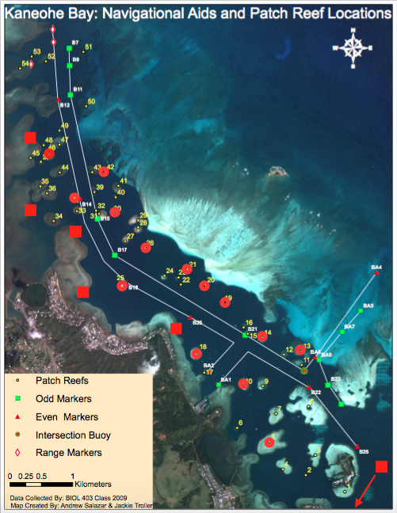

Tagged reefs to date: Circles indicate patch reefs, squares indicate fringing reefs

*Lab Work:*

Protocol overview

* DNA extraction via Ross Cunning’s CTAB-chloroform DNA Extraction and Purification protocol
  + 348 extractions completed to date
* qPCR analysis for presence of Clades C and/or D within each colony
  + 260 colonies completed to date
* qPCR analysis via Applied BioSystems StepOne Plus Software

*Data Analysis:*

Color morph determined from field photographs via Photoshop Bridge

Data analysis via RStudio

* Significant Chi-Squared tests to date:

Dominant Symbiont~Reef Area: **p=8.935e-11**

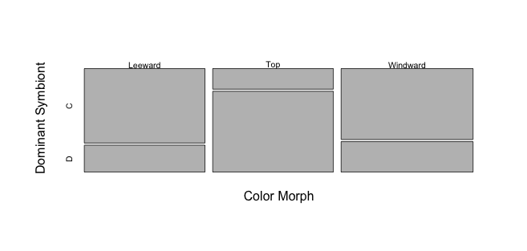

|  |  |  |
| --- | --- | --- |
|  | C | D |
| Leeward | 47 | 17 |
| Top | 13 | 51 |
| Windward | 49 | 21 |

Dominant Symbiont~Color Morph: **p=1.305e-13**

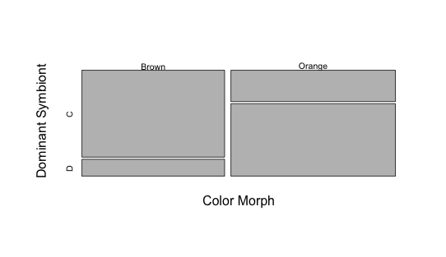

|  |  |  |
| --- | --- | --- |
|  | C | D |
| Brown | 77 | 15 |
| Orange | 32 | 74 |

Color Morph~Reef Area: **p=4.868e-8**

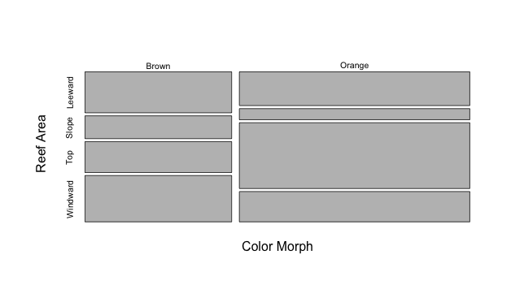

|  |  |  |
| --- | --- | --- |
|  | Brown | Orange |
| Leeward | 61 | 79 |
| Slope | 34 | 26 |
| Top | 46 | 154 |
| Windward | 69 | 71 |